**Practical Assessment – SQL Test – Emma Kevern**

Student ID: 99110320  
Student Name: Emma Kevern

**1.**

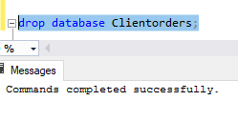 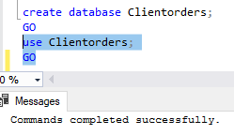

**2.**

SELECT [firstname], [lastname], [city]

FROM [client]

WHERE [city] = 'Dunedin';

GO

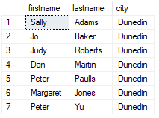

**3.**

SELECT [firstname], [lastname]

FROM [client]

WHERE [lastname] LIKE 'J%';

GO

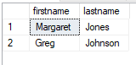

**4.**

SELECT [firstname], [lastname], [balance]

FROM [client]

WHERE [balance] BETWEEN 50 AND 150;

GO

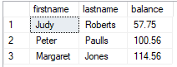

**5.**

SELECT [firstname], [lastname], [city]

FROM [client]

WHERE ([firstname] = 'Mary') AND ([lastname] = 'Nelson');

GO



**6.**

SELECT [firstname], [lastname],[balance], [city]

FROM [client]

WHERE ([balance] <= 200 ) AND ([city] = 'Dunedin');

GO

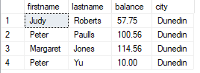

**7.**

SELECT [custref], [creditlimit], [balance], SUM([creditlimit] - [balance]) AS 'NewBalance'

FROM [dbo].[client]

GROUP BY [custref], [creditlimit], [balance];

GO

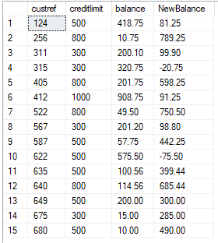

**8.**

SELECT [orderref], [partref], [quantity], [quotedPrice], SUM([quantity] * [quotedPrice]) AS 'LineTotal'

FROM [orderline]

GROUP BY [orderref], [partref], [quantity], [quotedPrice];

GO

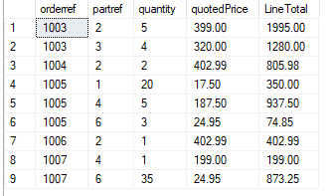

**9.**

SELECT [orderref], [orderdate]

FROM [custorder]

WHERE [orderdate] > '1999-06-01';

GO

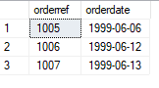

**10.**

SELECT [city], COUNT([city]) AS 'Number in each city'

FROM [client]

GROUP BY [city]

HAVING COUNT([city]) > 3;

GO

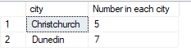

**11.**

SELECT [repref], SUM([balance]) AS 'Total balance'

FROM [dbo].[client]

GROUP BY [repref];

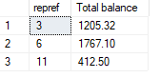

**12.**

SELECT [city], MAX([balance]) AS 'Maximum balance'

FROM [client]

GROUP BY [city];

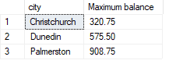

**13.**

SELECT [client].[firstname] + ' ' + [client].[lastname] AS 'Client name', [rep].[RepFirstname] + ' ' + [rep].[RepLastName] AS 'Rep Name'

FROM [client]

INNER JOIN [rep] ON [client].[repref] = [rep].[repref];

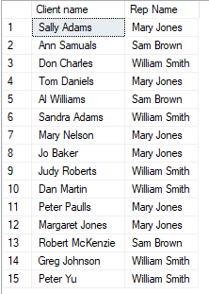

**14.**

SELECT [custorder].[orderref], [client].[firstname], [client].[lastname], [orderdate]

FROM [custorder]

INNER JOIN [client] ON [custorder].[custref] = [client].[custref];

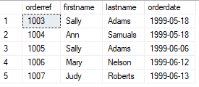

**15.**

SELECT [orderref], [description], [onHand]

FROM [orderline]

INNER JOIN [part] ON [orderline].[partref] = [part].[partref]

WHERE [orderref] = '1007';



**16.**

SELECT [orderref], [description],[quotedPrice], [quantity]

FROM [orderline]

INNER JOIN [part] ON [orderline].[partref] = [part].[partref]

ORDER BY [description];

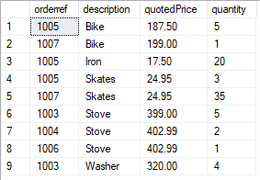

**17.**

SELECT [orderref], [description], [quotedPrice], [quantity]

FROM [orderline]

INNER JOIN [part] ON [orderline].[partref] = [part].[partref]

WHERE [quotedPrice] > 200;

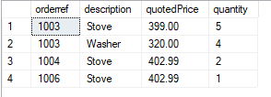

**18.**

SELECT [custorder].[orderref], .[orderdate], [firstname], [lastname], [description], [unitPrice]

FROM [custorder]

INNER JOIN [client] ON [custorder].[custref] = [client].[custref] AND [custorder].[orderref] = [orderline].[orderref]

ORDER BY [description];

**19.**

**20.**

**21.**

SELECT [RepFirstname] + ' ' + [RepLastName] AS 'Rep Name', SUM([balance]) AS 'Total Balance'

FROM [client]

INNER JOIN [rep] ON [client].[repref] = [rep].[repref]

GROUP BY [RepFirstname],[RepLastName];

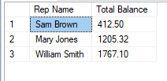

**22.**

SELECT ([orderref]), SUM([quantity] * [quotedPrice]) + [orderref] AS 'Total LineTotal'

FROM [orderline]

GROUP BY [orderref];

GO

